Oracle Database Administration Services
KE_Oracle_TNS Protocol Adapter Error

Submitted to



By



CIS, Wipro Limited

Document Details

Project Name | Innogy SE
Account | CIS
IT Component/Application Title | KE_Oracle_TNS Protocol Adapter Error
Current Version | 1.4
List of Contributors | Jiten Pansara , Kamlesh Sawant , Saurabh Nigam , Abhishek Kansal, Sreya Puthukudy
Customer Contact Information

Version History
(All revisions made to this document must be listed in chronological order. All revisions must be approved. Review and Approval can be done by an internal source or by the customer)
Version | Date of Revision | Description | Author | Reviewed By | Approved By
1.0 | 21-08-2016 | Intial Draft | Jiten Pansara | Saurabh Nigam | Mahesh Keshatwar
1.1 | 30-08-2016 | Document Completed | Jiten Pansara | Saurabh Nigam | Mahesh Keshatwar
1.2 | 17-05-2017 | Wipro and Innogy Logo changed | Kamlesh Sawant | Jiten Pansara | Mahesh Keshatwar
1.3 | 25-10-2017 | Updated document to Wipro Standard format with header and footer | Abhishek Kansal | Jiten Pansara | Santosh Badiger
1.4 | 16-12-2018 | Updated the content | Sreya Puthukudy | Jiten Pansara | Santosh Badiger

Error Description:
ORA-12560: TNS: protocol adaptor error
Impact:
This error will come if Listener is not up or problem in tnsnames or database is not up.
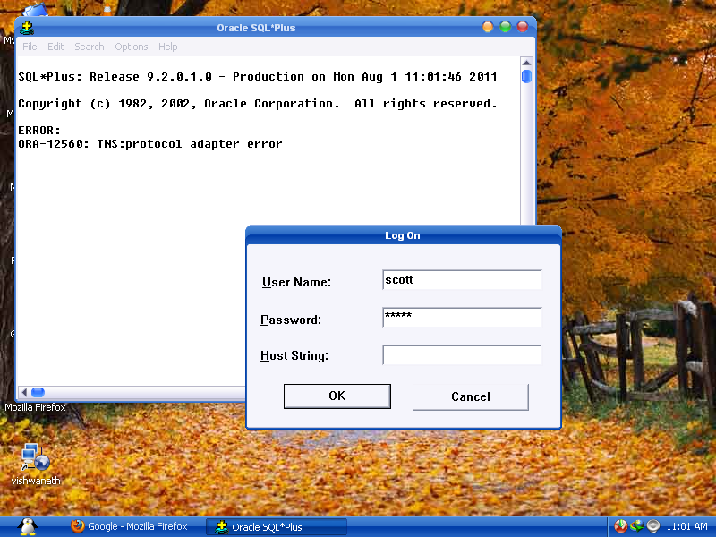

Workaround:
1.Check the listener status by executing
lsnrctl status
2.check the tnsnames entry is proper or not by
tnsping INSTANCENAME
3.Check the database is up or not by checking the service in windows ,(process in Unix)
4. If the database is not up than
5. set ORACLE_SID=<instance_name>
6. set oracle_home
7. set path
8. startup
9. For windows, If this won't resolve the issue, go to Start->Run-> Type Services.msc
10. Start/Restart both Oracle service & listener service- OracleServiceXE & OracleXETNSListener

